**Lesson21 Generalizing Virtual Machine in Azure**

**Notes:-**

**1-the process of generate image for the virtual machine is called generalizing virtual machine.**

**2-this operation means that when capture virtual machine and generate image for it, you cannot use this virtual machine as normal one (destructive mode).**

**Steps:-**

**1-on Azure portal > create virtual machine**

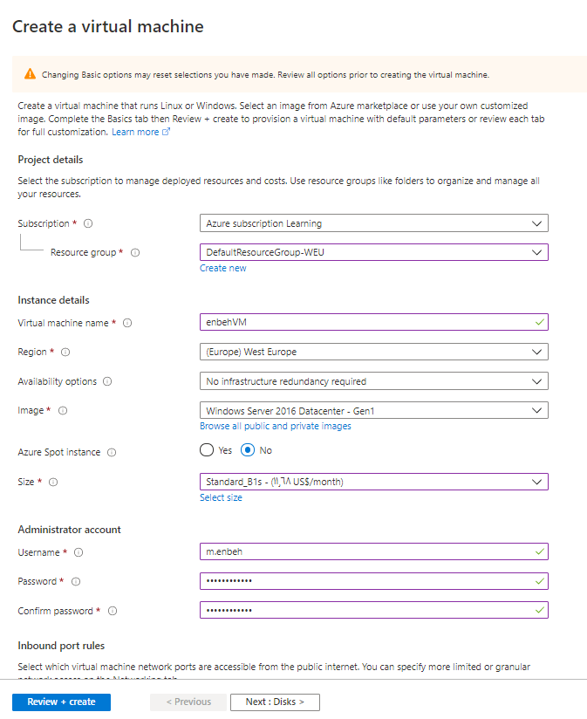

**(we see that we select the Azure instance which is B1s and choose the Azure subscription and Azure resource group and choose the Networking as HDD)**

**2-on Azure VM > on the path C:\Windows\System32\Sysprep\sysrep.exe and you can enable generalize with set shutdown option which means it will can create VM if image created on that VM on shutdown mode on the new virtual machines**

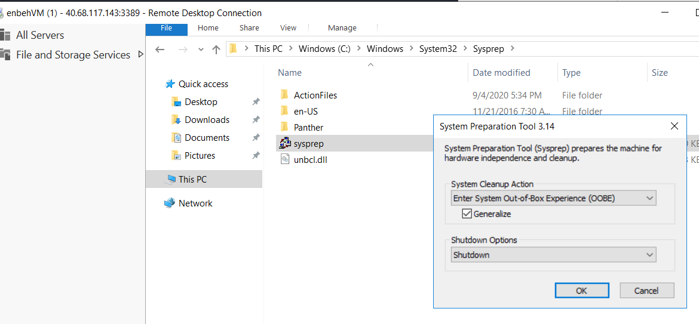

**3-on Azure Command Prompt we apply the following commands**

**//we apply login into Azure portal**

**Az login**

**//we stop the VM enbehVM on the resource group DefaultResourceGroup**

**az vm stop --resource-group DefaultResourceGroup-WEU --name enbehVM**

**4-on the Azure Portal > Virtual Machine > click on capture button to create new Image**

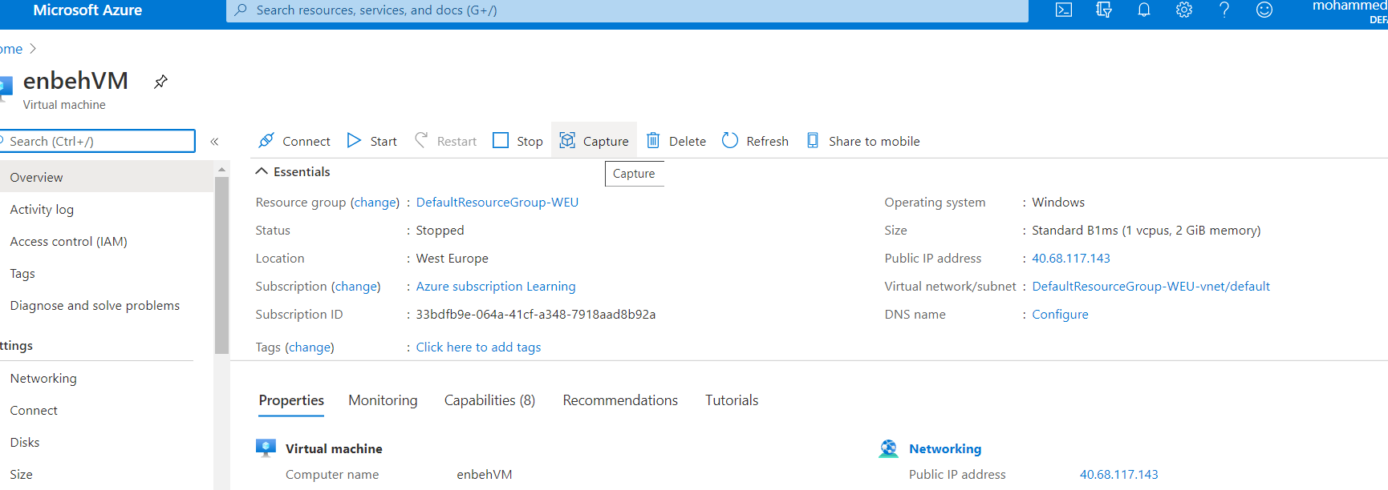

**5-we see on this image that you cannot use this VM when create an image for that VM as below**

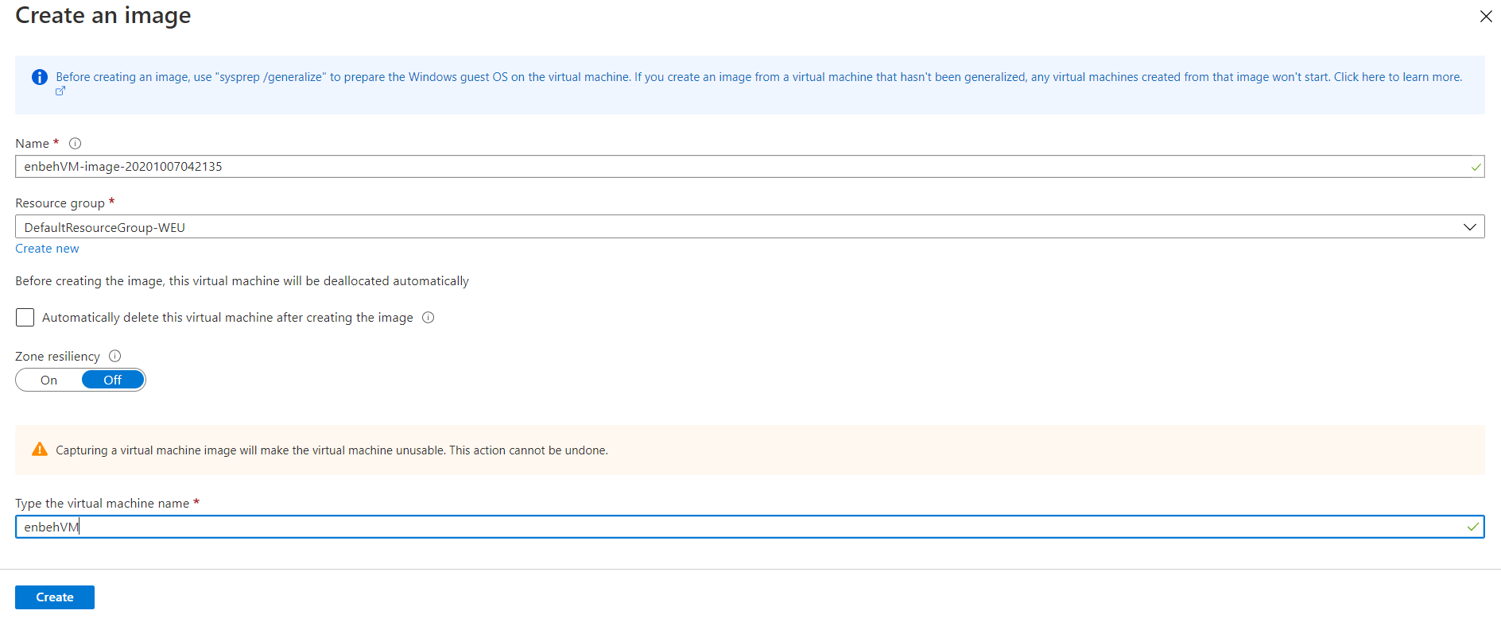

**6-we can see that the new Image is created and you can create VM for that image as below**

